# BCA Semester-V

# Subject: Networking Lecture-2

Topic: Network Media

# Prepared by Uttam Kumar Ghosh

BCA, Purnea College, Purnea

21-4-2020

## Coaxial Cable

*Coaxial cable* consists of a hollow outer cylindrical conductor that surrounds a single inner wire made of two conducting elements. One of these elements, located in the center of the cable, is a copper conductor. Surrounding the copper conductor is a layer of flexible insulation. Over this insulating material is a woven copper braid or metallic foil that acts both as the second wire in the circuit and as a shield for the inner conductor. This second layer, or shield, can help reduce the amount of outside interference. Covering this shield is the cable jacket.

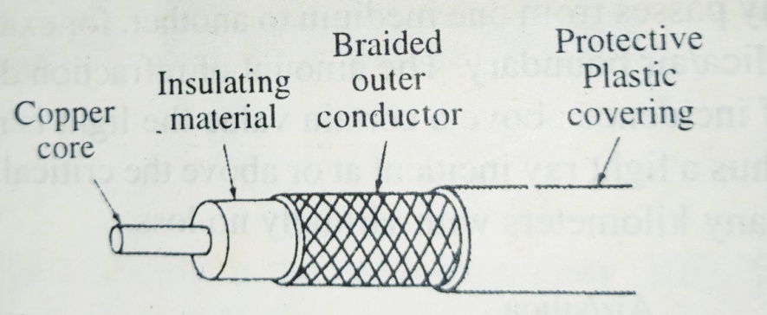

Fiber Optic Cable

Optical fiber is made-up of glass which acts as a waveguide for light over long distances. It uses a principle known as total internal reflection. [Fiber optic cable](https://www.firefold.com/fiber-optic-cables) is actually composed of two layers of glass: The core, which carries the actual light signal, and the cladding, which is a layer of glass surrounding the core. The cladding has a lower refractive index than the core. The light source is either LED or Laser diode which emit light pulses when an electrical current is applied . The detector is a photodiode, which generates an electrical pulse when light falls on it. When a light passes from one medium to another it reflects at the boundary in a certain angle. Thus a light ray incident at or above the critical angle is trapped inside the fiber and travels many kilometers. The principle of this technique is that the electronic signals are converted into light waves. This causes Total Internal Reflection within the core.

Optic fibers are used to connect servers and users in a variety of network settings and also help in increasing the accuracy and speed of data transmission.

